1. Create Test Plan -> Add -> Threads ->Thread Group rename to Thread Group_Users151

in the fields below, enter the number of users - 50

delay period before the start of the next user - 2

number of test repetitions - 3

Perform HTTP protocol settings - create in **Thread Group_Users50*->Add-> Config Element -> HTTP Request Defaults***

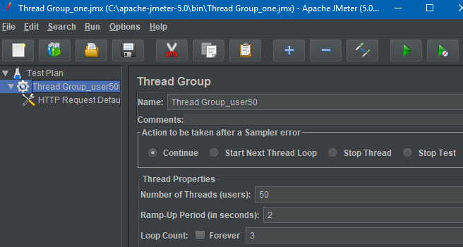

Picture 1

1.2. **Enter website address**

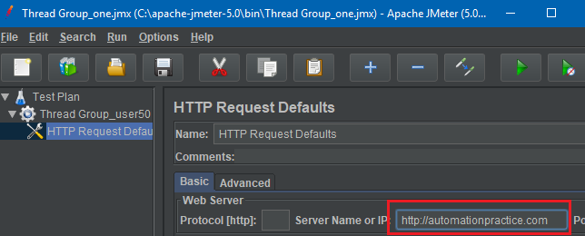

Picture 1.2

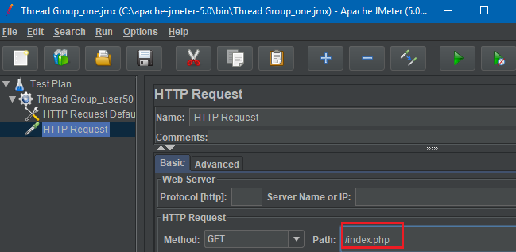

Picture 1.3

**Let's add elements to save** and visualize the results

**Thread Group_Users50 *->*** Add -> Listener -> Graph Results

**Thread Group_Users50 *->*** Add -> Listener -> View Results in Table

Thread **Group_Users50 -> Add** -> Listener -> Summary Report

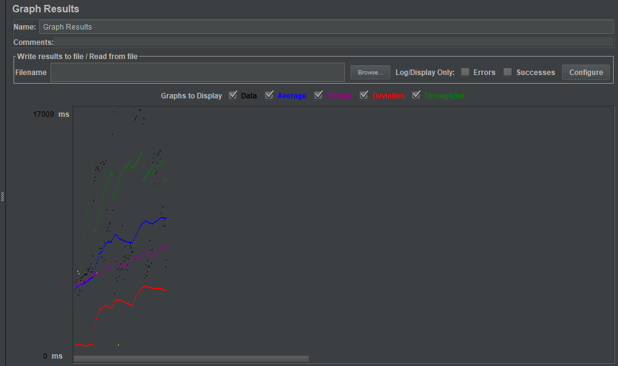

Picture 2.1

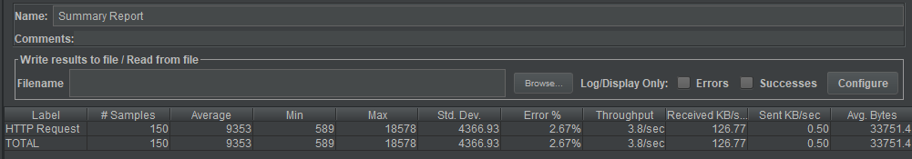

Picture 2.2

**Average** - average server response time, objective load graph.

**Median - the value of the** median (used in statistics, you can not use this data).

**Deviation** - error, standard deviation.

Throughput - the speed of the request itself [the green Throughput curve (performance, ~throughput, requests/per unit time) represents the number of requests processed by the server per minute].

**Label** : This is the name/URL for the specific HTTP request.

#Samples: Specifies the number of virtual users per request.

**Average**: The time it takes for all samples to execute a particular label.

**Min**: The shortest time that a sample takes for a particular mark.

**Std Dev.** : Shows the set of exceptions that deviate from the average sample response time. The smaller this value, the more consistent the data. The standard deviation must be less than or equal to half the average time for the label.

**KB/SEC**: The amount of data downloaded from the server during the performance test. In short, it is throughput measured in kilobytes per second.

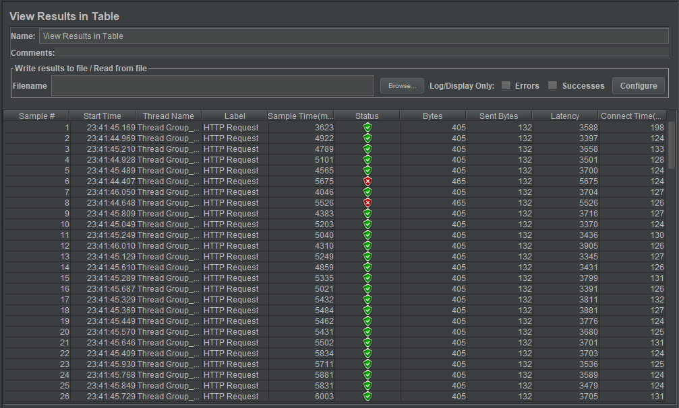

Picture 2.3

**Latency**: measures the latency just before a request is sent immediately after the first response is received. Thus, the time includes all the processing required to assemble the request, as well as the collection of the first part of the response, which in general will be longer than one byte. Protocol analyzers (like Wireshark) measure the time when bytes are actually sent/received over an interface. The JMeter time should be closer to what the browser or other application client experiences.

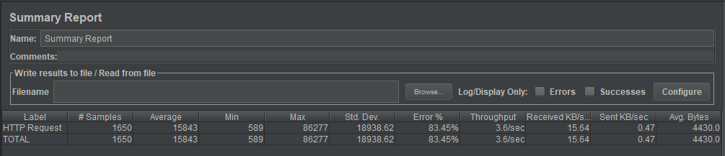

Picture 2.4

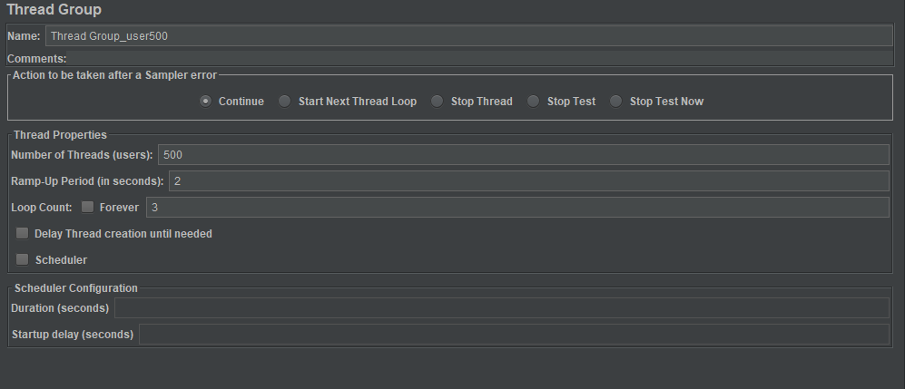

Picture 2.5

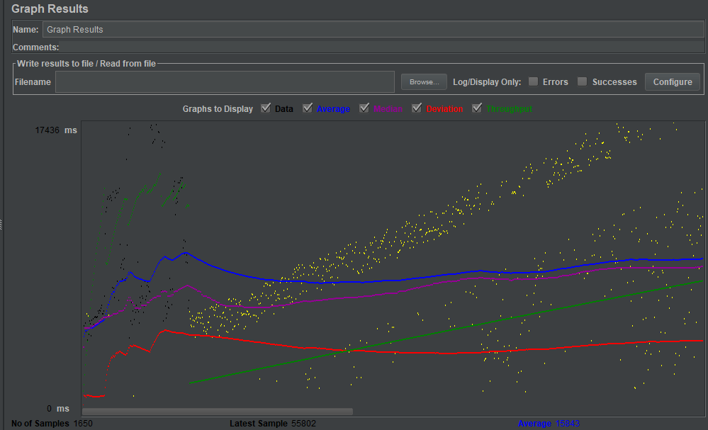

Picture 2.6

Number of test repetitions - 3

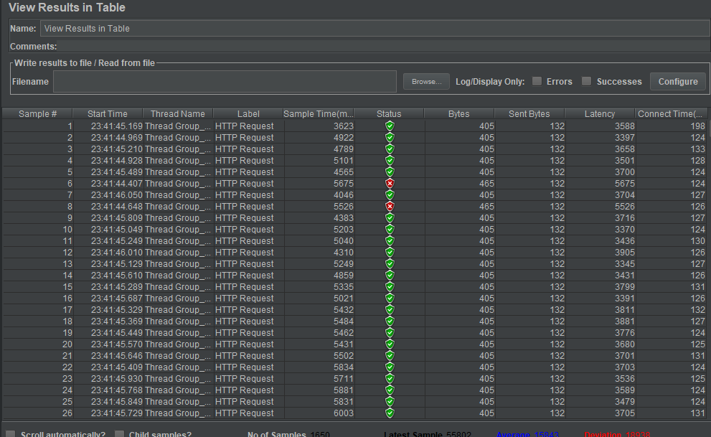

Picture 2.7



Picture 2.8

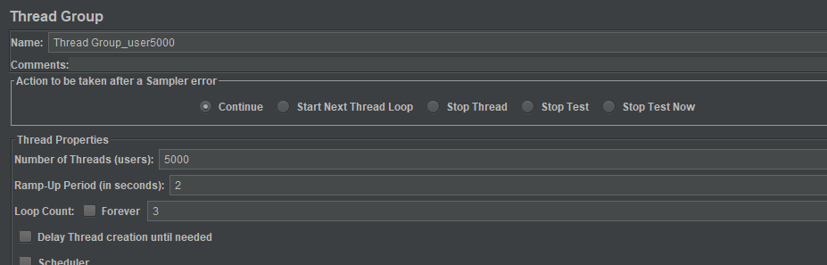

Picture 2.9

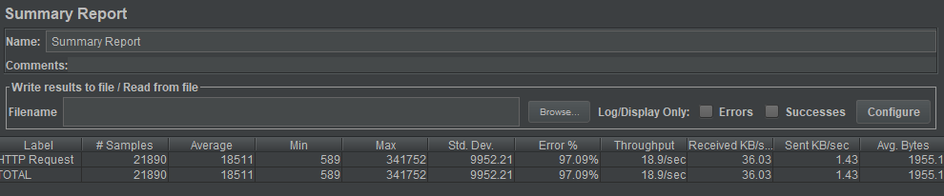

Picture 2.10

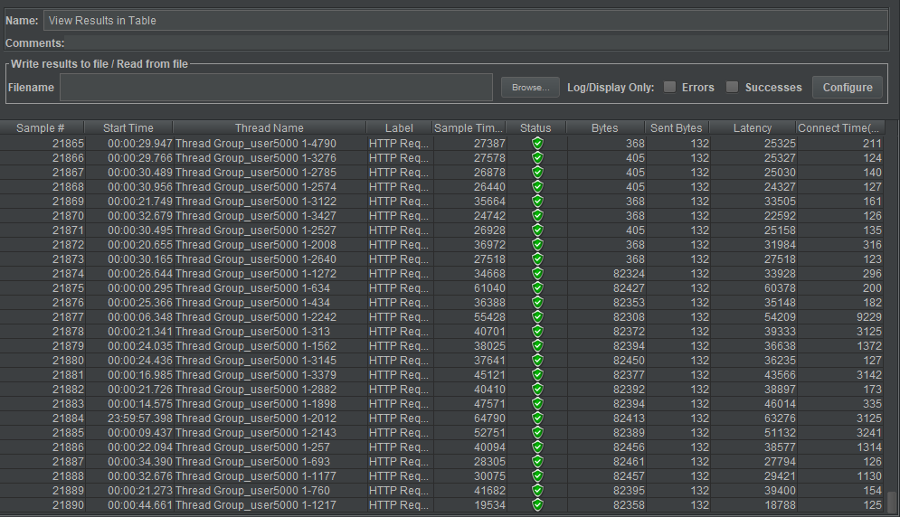

Picture 2.11

Delay period before the start of the next user - 2

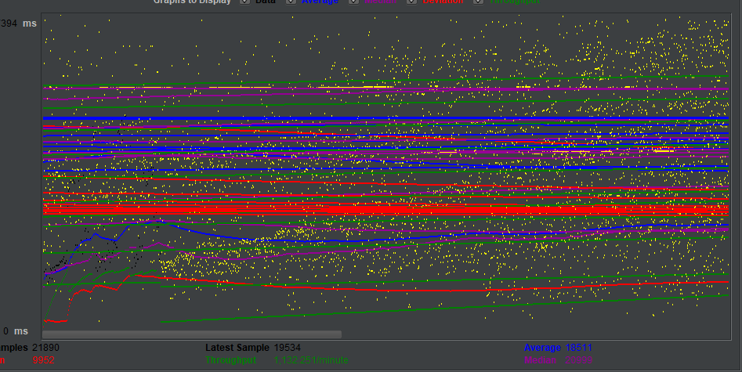

Picture 2.12

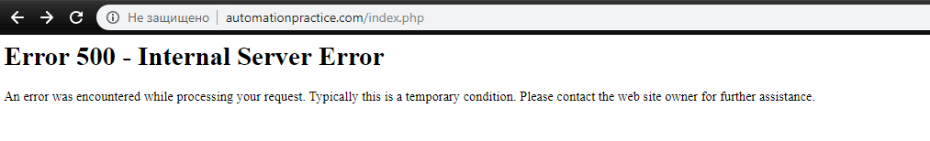

Picture 2.13

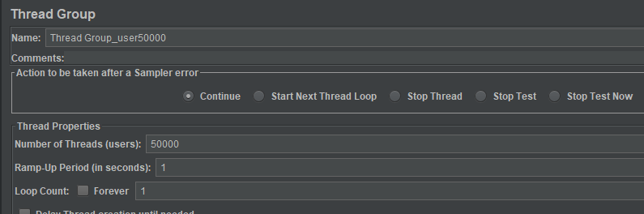

Picture 2.14

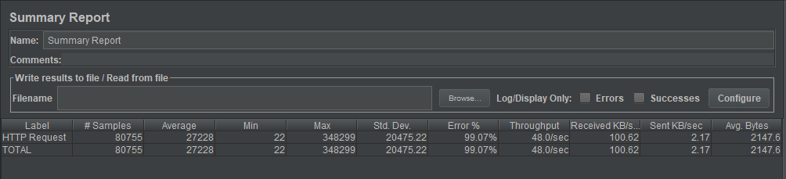

Picture 2.15

Delay period before the start of the next user - 1

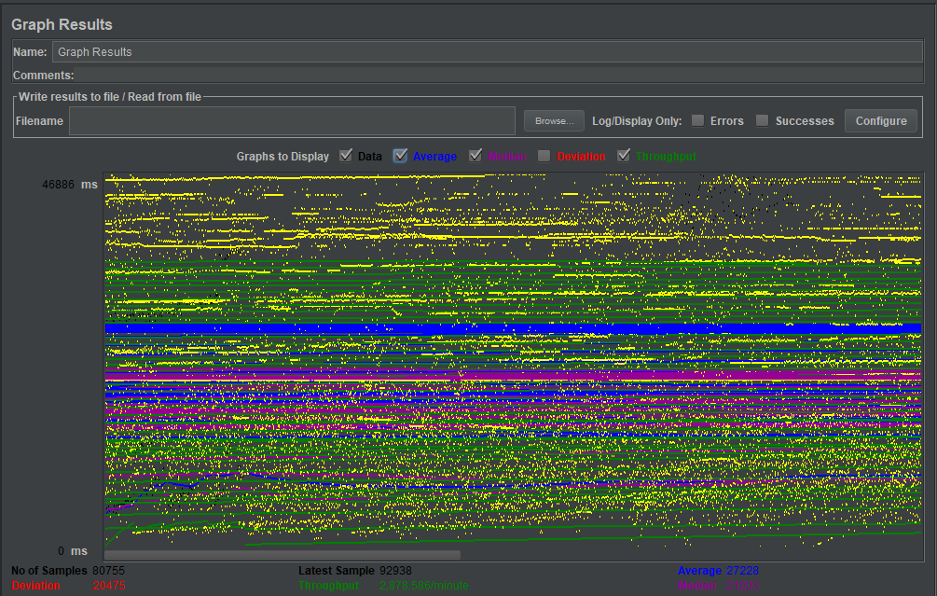

Picture 2.16

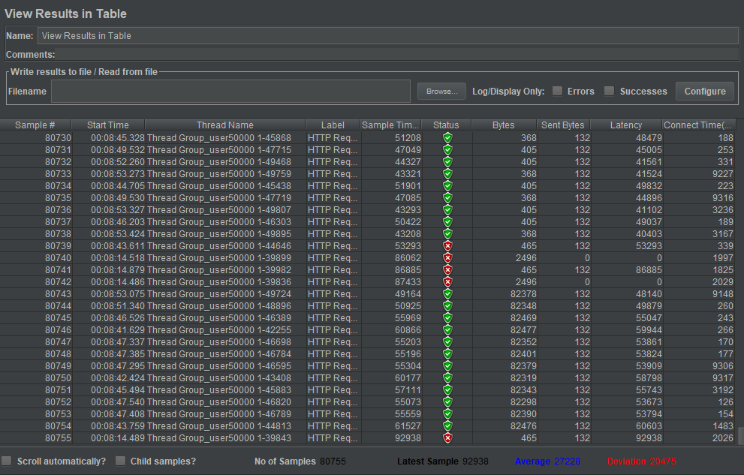

Picture 2.17